



The School of Technology

BSc (Hons) Computer Science (Software Engineering)

**Module: 5CI022**

Module Assesment

Module Leader: Ms. Sachini Vindya Gunasekara

Rashmika Jayasinghe (UOW 1900946)

Submission Date: 18.02.2020

Contents

UML Diagram 3

OOP Concepts and File Reading and File and Writing 3

Data Structures 3

Junit Testing 4

Classes 6

Administrator 6

Student 8

Instructor 9

Course 10

Module 10

# UML Diagram

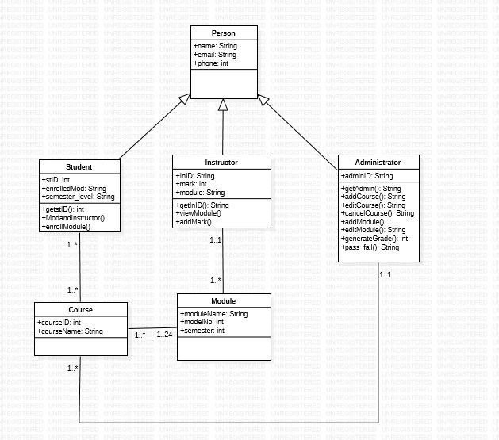

# OOP Concepts and File Reading and File and Writing

The developed program for the assessment is using some object-oriented concepts such as Inheritance, Encapsulation , data hiding. Data hiding and encapsulation are used in the program when the system some variable are declared as public and some are declared as private , protected. Inheritance is used when the Administrator , Instructor and Student classes are sub classes of the Person super class.

# Data Structures

In my program main data structure I used hashmap and it is used for data store. I also use two dimensional arrays it is also used for data store.

# Junit Testing

public void getstID() –get student ID as a input.

public void getLevel() - get semester level as a input.

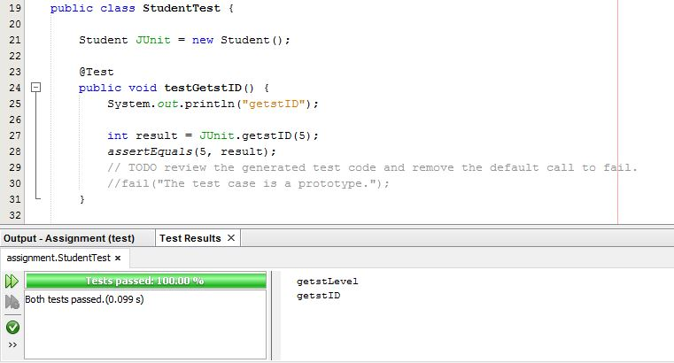

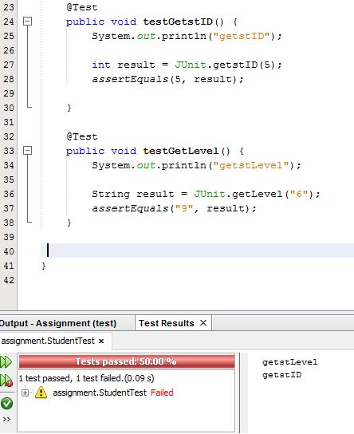

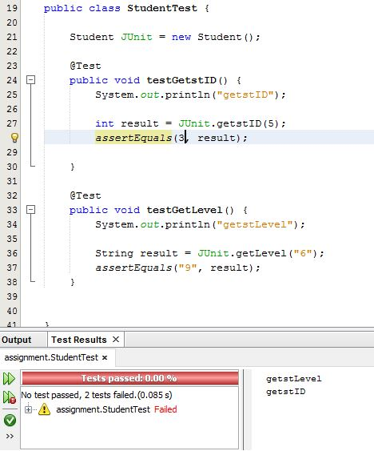

# Classes

## Administrator

* public void addCourse(String code, String courseName) – Add course code and course name

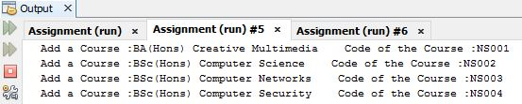

* protected void editCourse() - Edit course which already exists.



* public void cancelCourse() – Cancel a course which already exists.



* public void addModule(int moduleNo,String moduleName) –Add modules to the course.

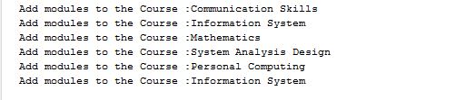

* public void editModule(int moduleNo,String moduleName) -Edit modules which already exists.



* public int generateGrade() - Enter average marks as a user input.

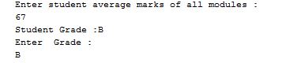

* public void pass_fail(String stdid) – Enter marks and grade as a user input and give which class that the student have.

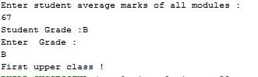

## Student

* public String getStID() – Enter student ID as a user input.



public void enrollModule(String uId, String modCode,String module) –

Allows a student object to be created and to enroll for all modules

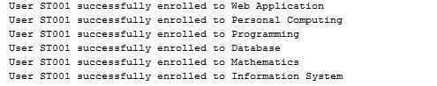

* public void ModandInstructor(String enrolledModCode,String Instructor) -Allow a student which instructor that they have.

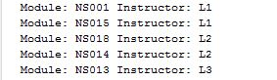

## Instructor

* public String getInID() – Get Instructor ID as user input.

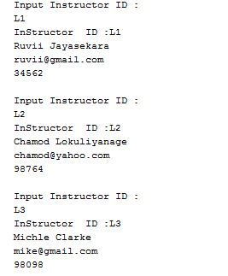

* public void viewModule(String InID, String modName) – Allow instructor to view modules that they can teach.

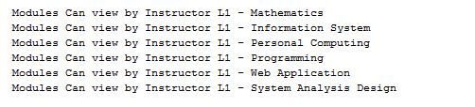

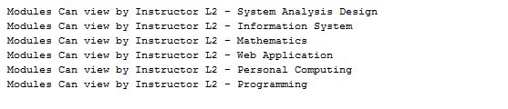

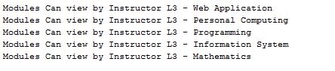

* public void addMark() – Allow instructor to add marks for the modules

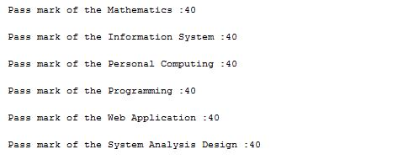

## Course

* public Course(String courseID,String courseName) – Creates a course object.

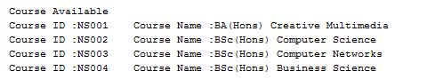

## Module

* public Module(int modelNo,String moduleName,String semester) – Create a module object.

